**Press release**

For immediate release

**Living together in harmony in the Montérégie’s agricultural zone**

**“OUR COUNTRYSIDE: A LIVING SPACE TO SHARE”**

**A story of noise**

**Montérégie, August 16th, 2021** – The countryside is a workplace for farm families. Noise from machinery, heavy vehicles, farm buildings, and animals can inconvenience the neighbours. The Montérégie UPA, 13 RCMs and Greater Longueuil want the public to know what efforts farmers make to mitigate the noises that are part of their daily lives. This initiative is part of the campaign to raise awareness about living together in harmony in the agricultural zone, which was launched with financial support from the Ministry for Agriculture, Fisheries, and Food (MAPAQ).

Over the years, many farmers have chosen to plant certain types of trees near their buildings to reduce noise propagation, and to install quieter ventilation or sound-absorbing materials. Knowing where the noise is coming from can make it less disturbing. Running fixed equipment, like grain dryers or irrigation pumps, is part of normal agricultural practices. These are usually located as far as possible from dwellings. Some farmers also warn neighbours who might be directly inconvenienced by the noise, and whenever possible, plan noisy work in the fields for opportune moments. Farmers must also respect provincial standards and municipal regulations for mitigating inconveniences associated with farming activities, including noise pollution.

It’s important to remember that farming activities are dependent on weather, and farm work is not easy. Living together in an agricultural environment sometimes requires patience and understanding.

Remember that this project, living together in harmony in the agricultural zone, has a regional scope. It aims to foster living together and dialogue between farmers and residents. The partners want to demystify beliefs, mitigate nuisances, and address issues related to agricultural work. It is important to the project’s initiators to highlight the multifunctionality of the agricultural zone as a place for living, working, and leisure.

1 / 2

**About the partners**

The project partners include: the RCMs of Acton, Beauharnois-Salaberry, Brome-Missisquoi, Haut-Richelieu, Haut-St-Laurent, Jardins-de-Napierville, Haute-Yamaska, Marguerite-D’Youville, Maskoutains, Pierre-De Saurel, Roussillon, Rouville, and Vallée-du-Richelieu, Greater Longueuil, the Montérégie UPA Federation (MUPAF), and the MAPAQ Montérégie regional office. These organizations are pooling resources and efforts to develop strategies and tools to ensure this campaign to raise awareness has a regional reach. The project was funded by the MAPAQ’s Territories program: Bio-food priorities and will continue through October 2021.

- 30 -

Sources:

Living Together Project:

Caroline Deschamps, Montérégie UPA Federation (MUPAF)

450-774-9154, extension 5227 [cdeschamps@upa.qc.ca](mailto:cdeschamps@upa.qc.ca)

Promotional materials for the campaign:

Brigitte Marcotte, Expansion PME

450-446-2880, extension 2703 bmarcotte@expansionpme.org

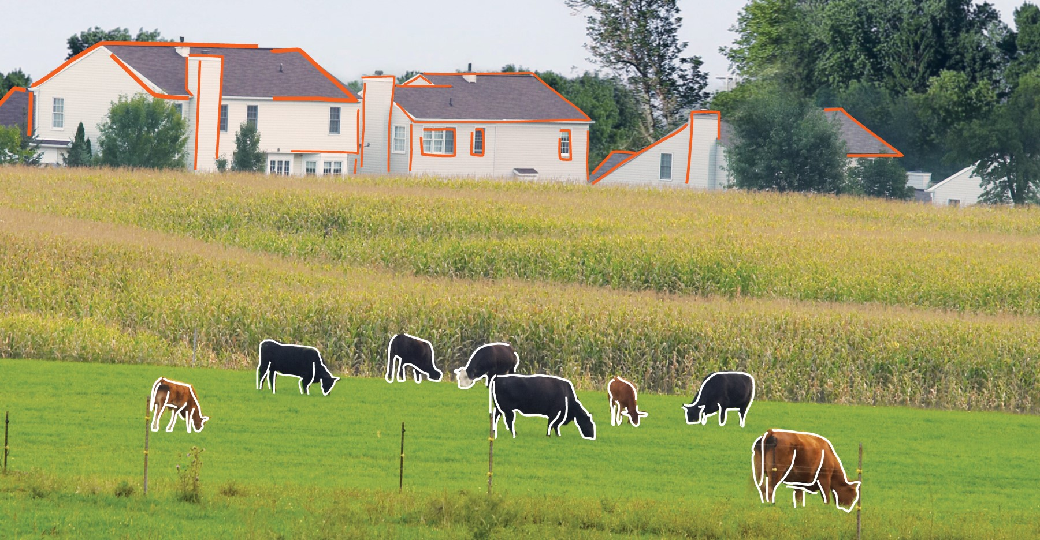

2 / 2