PRESS RELEASE
For immediate release

Living together in harmony in the Montérégie’s agricultural zone
“OUR COUNTRYSIDE: A LIVING SPACE TO SHARE”
Share the road

Montérégie, September 13th, 2021 – Roads everywhere are increasingly in demand, and this requires every road user to share them, whether we are driving cars, heavy equipment, or bicycles. The Montérégie UPA, 13 RCMs, and Greater Longueuil want to inform the public about the importance of sharing the road in the agricultural milieu. This initiative is part of the campaign to raise awareness about living together in harmony in the agricultural zone, which was launched with financial support from the Ministry for Agriculture, Fisheries, and Food (MAPAQ).

Sharing the road is a challenge when the vehicle in front of us, or an oncoming one, is an imposing tractor, often very large and moving slowly, as the speed limit for farm vehicles with equipment is 40 km/h. While they are allowed to drive on the roads, they are prohibited from driving on the shoulder. Patience, prudence, and mutual respect are the golden rule. This is for everyone’s safety.

How to pass farm machinery
The Highway Safety Code allows drivers to cross a single or double solid line to pass farm machinery, but only if the passing maneuver is without danger to themselves or other road users. To do this safely, a driver must check that the lane is free for a sufficient distance before beginning the maneuver, and that the tractor driver is not preparing to turn left as it enters a field, for example. Maintaining a safe distance from the farm vehicle, before and after passing, is also a good habit to adopt, as is slowing down when approaching farms or entry points for cultivated fields.

The presence of farm machinery on the roads is higher at certain times of the year, especially in the fall during harvest season and in the spring during planting season. It is essential to adopt cautious, understanding behaviour to avoid collisions and accidents that can lead to serious injuries or death. We must all share the road.

1 / 2

Remember that this project, living together in harmony in the agricultural zone, has a regional scope. It aims to foster living together and dialogue between farmers and residents. The partners want to demystify beliefs, mitigate nuisances, and address issues related to agricultural work. It is important to the project’s initiators to highlight the multifunctionality of the agricultural zone as a place for living, working, and leisure.

About the partners
The project partners include: the RCMs of Acton, Beauharnois-Salaberry, Brome-Missisquoi, Haut-Richelieu, Haut-St-Laurent, Jardins-de-Napierville, Haute-Yamaska, Marguerite-D’Youville, Maskoutains, Pierre-De Saurel, Roussillon, Rouville, and Vallée-du-Richelieu, Greater Longueuil, the Montérégie UPA Federation (MUPAF), and the MAPAQ Montérégie regional office. These organizations are pooling resources and efforts to develop strategies and tools to ensure this campaign to raise awareness has a regional reach. The project was funded by the MAPAQ’s Territories program: Bio-food priorities and will continue through October 2021.

- 30 -
Sources:
Living Together Project:
Caroline Deschamps, Montérégie UPA Federation (MUPAF)
450-774-9154, extension 5227 cdeschamps@upa.qc.ca

Promotional materials for the campaign:
Brigitte Marcotte, Expansion PME
450-446-2880, extension 2703 bmarcotte@expansionpme.org

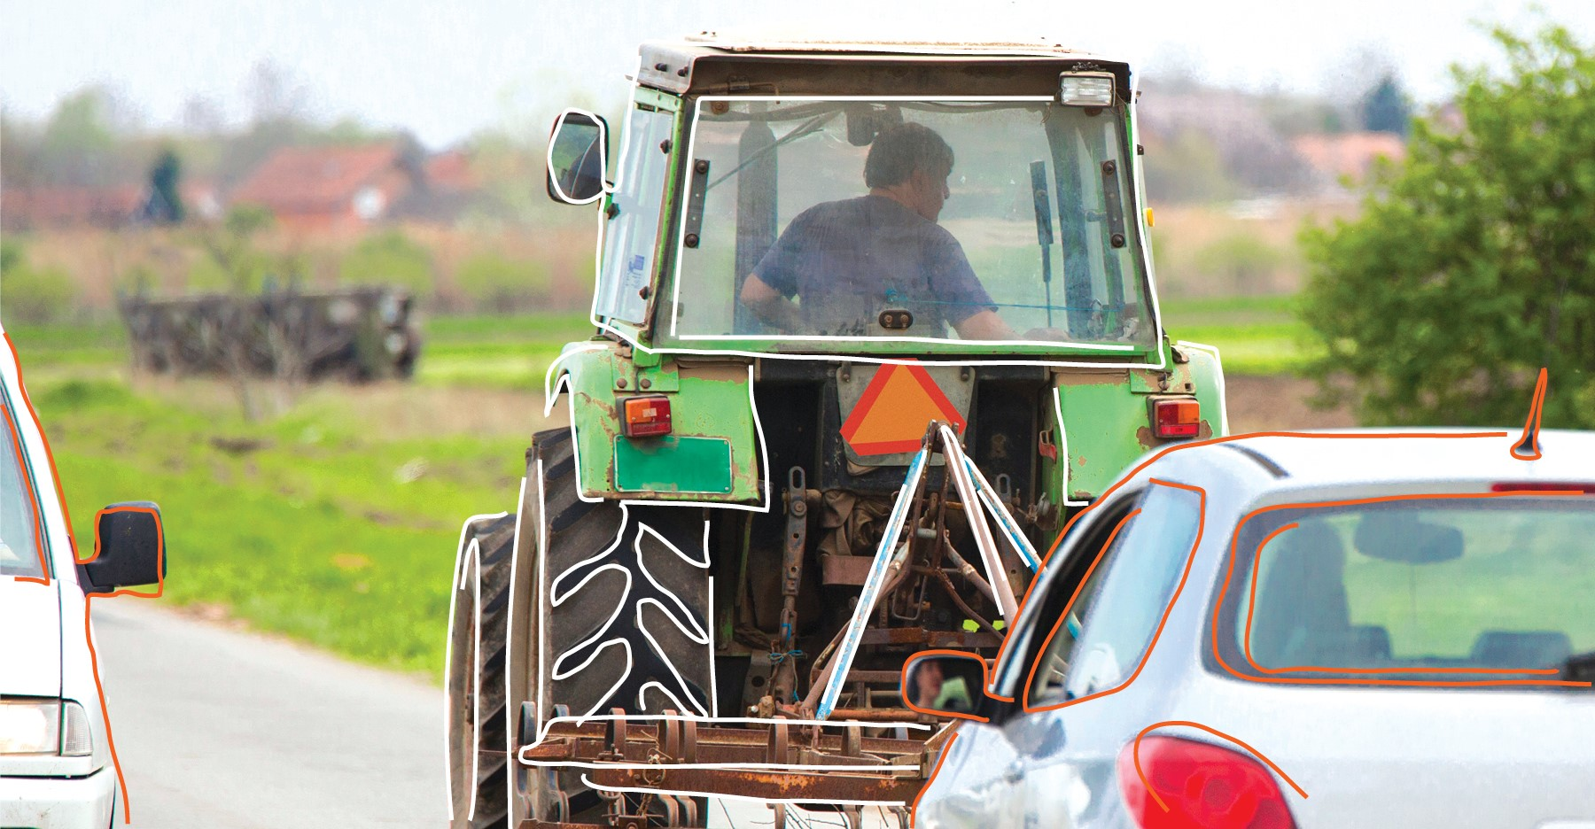

2 / 2

