Press release
For immediate release

Living together in harmony in the Montérégie’s agricultural zone
“OUR COUNTRYSIDE: A LIVING SPACE TO SHARE” – Soil health

Montérégie, May 31st, 2021 – The Montérégie UPA, 13 RCMs and Greater Longueuil want the public to know how important it is to preserve the health of agricultural soils. This initiative is part of the campaign to raise awareness about living together in harmony in the agricultural zone, which was launched with financial support from the Ministry for Agriculture, Fisheries, and Food (MAPAQ).

Soil health
An essential resource for the growth and vitality of crops, the soil is the most precious asset for farmers and the main component for their work. This is why farmers take care of the land. Protecting the precious resource of healthy soil means maintaining a composition rich in organic matter and nutrients, avoiding wind and water erosion, taking care not to damage the soil with agricultural machinery, and preventing the soil structure from becoming too compact or unstable.

Healthy soil is fertile and therefore productive. Not only does it allow plants to grow well, but it also plays an essential role in the water cycle, in purification, in the degradation of pollutants, in supporting biodiversity, and in reducing greenhouse gases. To maintain soil fertility, farmers apply fertilizers but avoid using more than is needed. Fertilizing crops is an activity that is closely monitored in Québec. Farm fertilizers (like slurry) are also stored in watertight and safe structures.

To maintain or improve soil health in the fields, farmers also use a number of other practices: crop rotation, ground-cover plants to prevent erosion and feed the soil, reducing the use of farm machinery, direct-seeding without tillage, and leaving behind crop residues to fertilize the soil…

The soil is a living ecosystem that must not become degraded or depleted. Whether in the crop fields or in the private garden, it is essential to keep our soils healthy so that what is growing is nourished and can grow to nourish us in turn.

1 / 2

Remember that this project, living together in harmony in the agricultural zone, has a regional scope. It aims to foster living together and dialogue between farmers and residents. The partners want to demystify beliefs, mitigate nuisances, and address issues related to agricultural work. It is important to the project’s initiators to highlight the multifunctionality of the agricultural zone as a place for living, working, and leisure.

About the partners
The project partners include: the RCMs of Acton, Beauharnois-Salaberry, Brome-Missisquoi, Haut-Richelieu, Haut-St-Laurent, Jardins-de-Napierville, Haute-Yamaska, Marguerite-D’Youville, Maskoutains, Pierre-De Saurel, Roussillon, Rouville, and Vallée-du-Richelieu, Greater Longueuil, the Montérégie UPA Federation (MUPAF), and the MAPAQ Montérégie regional office. These organizations are pooling resources and efforts to develop strategies and tools to ensure this campaign to raise awareness has a regional reach. The project was funded by the MAPAQ’s Territories program: Bio-food priorities and will continue through October 2021.

- 30 -
Sources:
Living Together Project:
Caroline Deschamps, Montérégie UPA Federation (MUPAF)
450-774-9154, extension 5227 cdeschamps@upa.qc.ca

Promotional materials for the campaign:
Brigitte Marcotte, Expansion PME
450-446-2880, extension 2703 bmarcotte@expansionpme.org

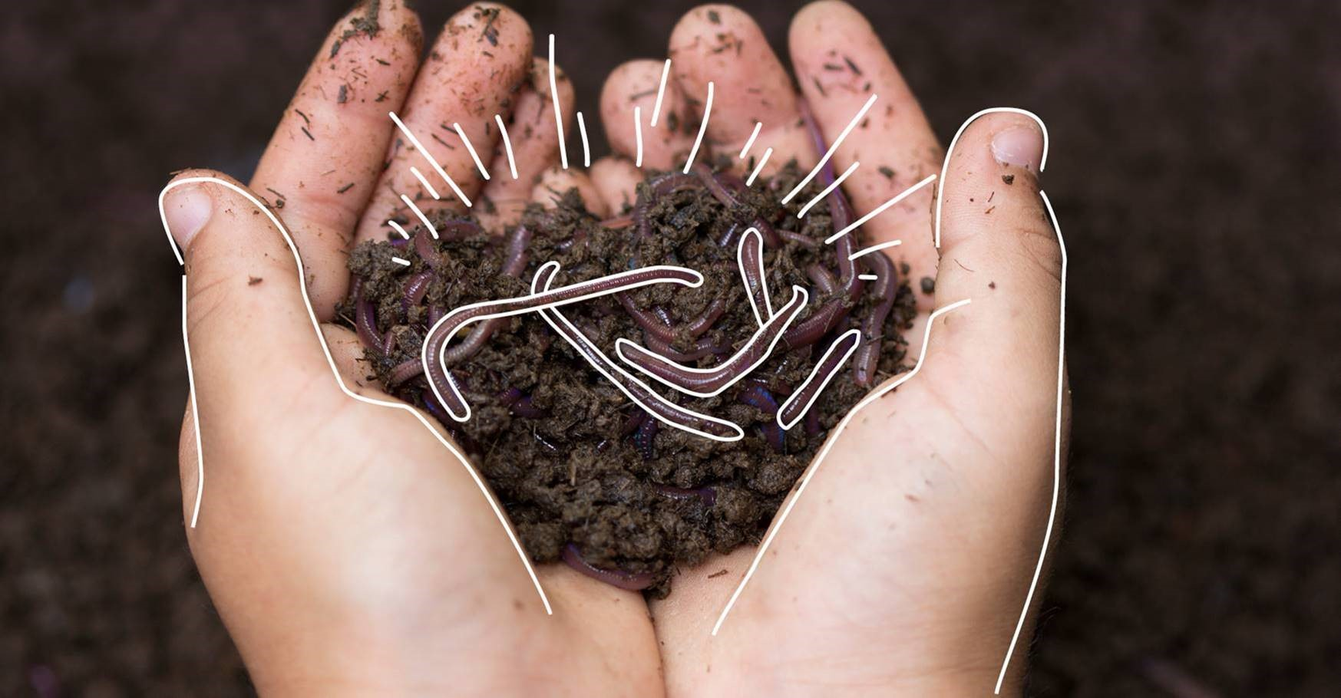

2 / 2

