**PRESS RELEASE**

For immediate release

**Living together in harmony in the Montérégie’s agricultural zone**

**Day camp activities to introduce**

**children to the world of agriculture**

**Montérégie, June 14th, 2021 –** Again this summer, the region’s municipal day camps will offer activities to raise children’s awareness about the realities of agriculture in the Montérégie. This initiative is part of the awareness-raising campaign for living together in harmony in the agricultural zone, initiated by the Montérégie UPA, 13 Montérégie RCMs, and Greater Longueuil, with support from the Ministry for Agriculture, Fisheries, and Food (MAPAQ).

Starting the week of June 28th and for the next eight weeks, in collaboration with the recreation department of the participating municipalities, animators from the local business, Agro-Passion, based in Marieville, will travel to dozens of towns and villages throughout the Montérégie to teach children about the realities of agriculture. Through play-based and instructional activities, children ages 7 to 12 will be introduced to the rural world that surrounds them and discover the importance of living together in harmony in the agricultural milieu.

***“L’agriculture, ma voisine !”***

Lasting about 1 hour 15 minutes, the activities include interactive presentations, fun and instructive questionnaires, high-energy themed games, and a planting session. The main themes connected to agricultural activities are discussed: noise, odours, sharing the road, soil health, and water. The activities allow children to understand the need for and use of some of these farming practices. They will also discover the advantages of living in an agricultural region and will become aware of the benefits. More than 2,000 children will be able to enjoy these activities during the 2021 summer season. These activities have already been adapted to respect current sanitary health requirements.

**Project partners**

The project partners are: the RCMs of Acton, Beauharnois-Salaberry, Brome-Missisquoi, Haut-Richelieu, Haut-St-Laurent, Jardins-de-Napierville, Haute-Yamaska, Marguerite-D’Youville, Maskoutains, Pierre-De Saurel, Roussillon, Rouville, and Vallée-du-Richelieu, Greater Longueuil, the Montérégie UPA Federation (MUPAF) and the MAPAQ’s Montérégie regional office. These organizations are pooling resources and efforts to develop strategies and tools to ensure this campaign to raise awareness has a regional reach. The project is funded by the MAPAQ’s Territories program: Bio-food priorities and will continue through October 2021.

- 30 -

**Sources:**

Living Together Project:

Caroline Deschamps, Montérégie UPA Federation (MUPAF)

450-774-9154, extension 5227 [cdeschamps@upa.qc.ca](mailto:cdeschamps@upa.qc.ca)

Promotional materials for the campaign:

Brigitte Marcotte, Expansion PME

450 446-2880, extension 2703 bmarcotte@expansionpme.org

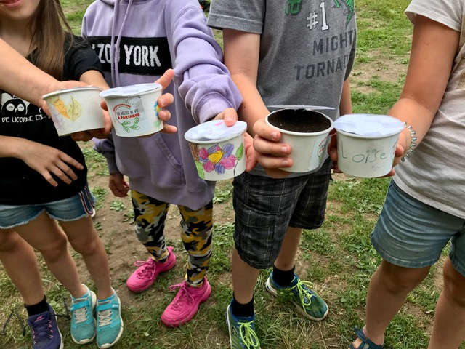

**« L’agriculture, ma voisine! » activity will be held in the day camps of the following municipalities for the summer of 2021 :**

Acton Vale – Friday, July 23

Ange-Gardien – Tuesday, July 6

Beauharnois – Monday, July 26

Bedford – Monday, July 19

Bedford Canton –Tuesday, July 20

Brossard – Friday, July 2 and Friday, July 9

Frelighsburg – Monday, July 12

Granby – Wednesday, June 30

Hemmingford – Wednesday, August 11

Longueuil – Thursday, July 22 and Friday, July 23

Massueville – Tuesday, July 13

McMasterville – Thursday, August 19

Mercier – Friday, July 23

Mont-Saint-Grégoire – Tuesday, August 17

Mont-Saint-Hilaire – Tuesday, July 13

Napierville et Saint-Cyprien – Tuesday, August 17

Otterburn Park – Friday, July 16

Richelieu – Tuesday, July 6

Roxton Falls – Thursday, July 1st

Roxton Pond – Friday, July 9

Saint-Alexandre – Thursday, August 19

Saint-Alphonse-de-Granby – Thursday, July 1st

Saint-Amable – Tuesday, August 10

Saint-Blaise-sur-Richelieu – Wednesday, July 21

Saint-Bruno-de-Montarville – Thursday, July 22

Saint-Charles-sur-Richelieu – Wednesday, July 14

Saint-David – Tuesday, June 29

Saint-Denis-sur-Richelieu – Wednesday, July 14

Saint-Étienne-de-Beauharnois – Monday, August 16

Saint-Hugues – Monday, August 9

Saint-Isidore – Wednesday, August 11

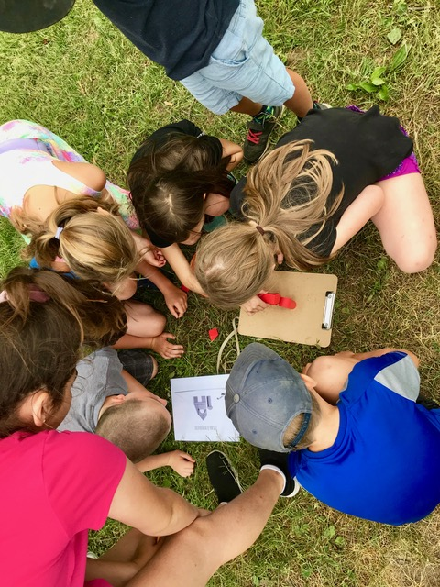Saint-Jean-Baptiste – Tuesday, July 27

Saint-Jean-sur-Richelieu – Monday, July 19

Saint-Joachim-de-Shefford – Monday, August 16

Saint-Lambert – Wednesday, July 7

Saint-Louis – Monday, August 9

Saint-Louis-de-Gonzague – Thursday, July 8

Saint-Mathias-sur-Richelieu – Friday, July 16

Saint-Mathieu – Monday, July 5

Saint-Mathieu-de-Beloeil – Friday, July 23

Saint-Michel – Tuesday, August 17

Saint-Nazaire d’Acton – Friday, August 13

Saint-Paul-de-l’Île-aux-Noix – Wednesday, July 21

Saint-Philippe – Monday, July 19

Saint-Robert – Tuesday, July 20

Saint-Théodore d’Acton – Friday, August 13

Saint-Valérien-de-Milton – Wednesday, June 30

Sainte-Angèle-de-Monnoir – Tuesday, July 20

Sainte-Anne-de- Sabrevois – Monday, July 12

Sainte-Barbe – Thursday, July 22

Sainte-Cécile-de-Milton – Thursday, July 15

Sainte-Christine – Wednesday, August 18

Sainte-Hélène-de-Bagot – Monday, July 5

Sainte-Julie – Wednesday, July 7

Sainte-Madeleine – Tuesday, July 27

Sainte-Martine – Thursday, July 8

Sainte-Victoire-de-Sorel – Tuesday, June 29

Salaberry-de-Valleyfield – Monday, July 26

Sutton – Wednesday, July 21

Upton – Thursday, August 12

Varennes – Tuesday, August 10

Verchères – Wednesday, August 18

Waterloo – Thursday, August 12

Yamaska – Friday, July 2

