**Press release**

For immediate release

**Living together in harmony in the Montérégie’s agricultural zone**

**“OUR COUNTRYSIDE: A LIVING SPACE TO SHARE”**

**Pesticides**

**Montérégie, July 5th, 2021** – Pesticides are used to protect crops from losses caused by pest insects, invasive plants, and plant diseases. The Montérégie UPA, 13 RCMs, and Greater Longueuil aim to inform the public about efforts farmers are making to reduce the use of pesticides. This initiative is part of the campaign to raise awareness about living together in harmony in the agricultural zone, which was launched with financial support from the Ministry of Agriculture, Fisheries and Food (MAPAQ).

**The theme of pesticides**

Farmers are aware of the key issues around pesticides. By protecting biodiversity, surface and groundwater quality, and soil health, farmers ensure both the viability of their farms and the health of the population, protecting their families, employees, and neighbours, and promoting food safety. With some of the lowest pesticide use in the world (2.9 kg per hectare), Québec is a leader in reducing the average amount of pesticides applied. Over a 10-year period (2006-2017), the province reduced pesticide use by 14%.

Moreover, the products used in agriculture must be authorized by government agencies. Health Canada sets strict controls on pesticide use and the precise limits for amounts of trace pesticides that can be present on food products. This limit is between 100 and 3,000 times lower than the established safety limit. In addition to limits on which products can be applied, the use of certain products requires supervision by an agronomist. Finally, farmers must also respect limiting distances between pesticide application areas and buildings, waterways, and water collection sites.

Family farmers are reducing their use of pesticides by employing screening techniques in the field, crop rotation, and integrated management, meaning that they know their crops, crop enemies, and the allies they can find in the ecosystem. Through these alternative techniques for prevention, monitoring, and intervention, some farmers have had success in significantly reducing the application of agrochemical products.

1 / 2

Remember that this project, living together in harmony in the agricultural zone, has a regional scope. It aims to foster living together and dialogue between farmers and residents. The different partners want to demystify beliefs, mitigate nuisances, and address issues related to agricultural work. It is important to the project’s initiators to highlight the multifunctionality of the agricultural zone as a place for living, working, and leisure.

**About the partners**

The project partners include: the RCMs of Acton, Beauharnois-Salaberry, Brome-Missisquoi, Haut-Richelieu, Haut-St-Laurent, Jardins-de-Napierville, Haute-Yamaska, Marguerite-D’Youville, Maskoutains, Pierre-De Saurel, Roussillon, Rouville, and Vallée-du-Richelieu, Greater Longueuil, the Montérégie UPA Federation (MUPAF), and the MAPAQ Montérégie regional office. These organizations are pooling resources and efforts to develop strategies and tools to ensure this campaign to raise awareness has a regional reach. The project was funded by the MAPAQ’s Territories program: Bio-food priorities and will continue through October 2021.

- 30 -

Sources:

Living Together Project:

Caroline Deschamps, Montérégie UPA Federation (MUPAF)

450-774-9154, extension 5227 [cdeschamps@upa.qc.ca](mailto:cdeschamps@upa.qc.ca)

Promotional materials for the campaign:

Brigitte Marcotte, Expansion PME

450-446-2880, extension 2703 bmarcotte@expansionpme.org

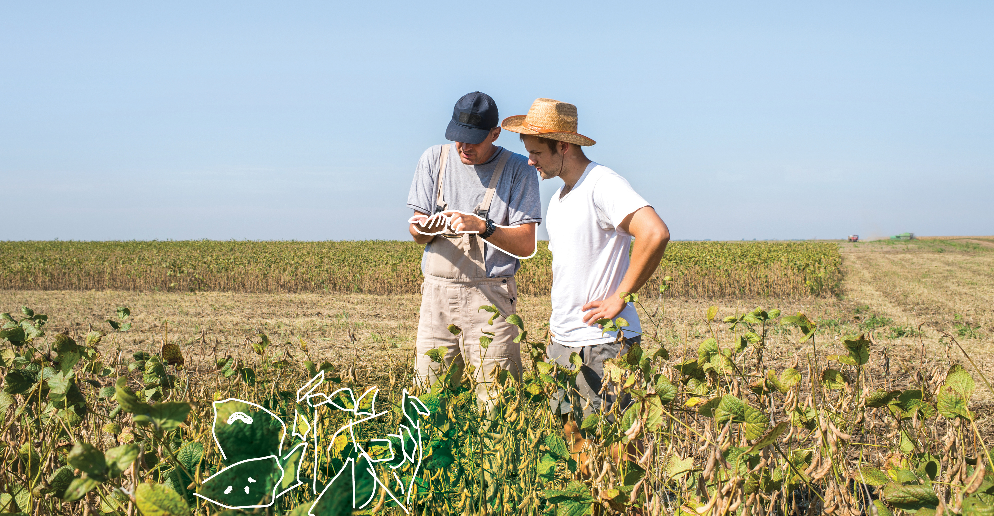

2 / 2