**Press release**

For immediate release

**Living together in harmony in the Montérégie’s agricultural zone**

**“OUR COUNTRYSIDE: A LIVING SPACE TO SHARE”**

**Water**

**Montérégie, July 26th, 2021** – Water is essential for life and indispensable for agriculture. As key players, farmers are implementing techniques to limit waste and reduce the impact of farming activities. The Montérégie UPA, 13 RCMs, and Greater Longueuil aim to inform the public about efforts farmers are making to protect this resource. This initiative is part of the campaign to raise awareness about living together in harmony in the agricultural zone, which was launched with financial support from the Ministry of Agriculture, Fisheries and Food (MAPAQ).

**The theme of water**

As water users, agri-businesses develop practices that respect this essential resource, for example, by watering at the base of plants or by using efficient irrigation systems. Preserving the water supply is essential for the future of farming. Protecting aquatic environments is also a priority for farmers. Particular attention is paid to erosion.

To avoid runoff water carrying soil particles away from the fields, practices have been adopted to promote the absorption of water into the soil. Notably, these include plantings between the field and the waterway. These uncultivated portions of land, called riparian strips, are ceded by farms to play an important role in preventing erosion by forming a buffer zone between the fields and waterways.

For their part, livestock farmers have developed state-of-the-art watertight storage structures to manage natural fertilizers. Finally, sustainable alternatives in integrated control, like the use of natural insect predators, significantly reduce the use of fertilizers and pesticides.

In the agricultural milieu, farmers are taking mitigation measures to ensure a sustainable agriculture, in accordance with government policies established to protect, restore, and clean waterways and drainage ditches.

1 / 2

Remember that this project, living together in harmony in the agricultural zone, has a regional scope. It aims to foster living together and dialogue between farmers and residents. The different partners want to demystify beliefs, mitigate nuisances, and address issues related to agricultural work. It is important to the project’s initiators to highlight the multifunctionality of the agricultural zone as a place for living, working, and leisure.

**About the partners**

The project partners include: the RCMs of Acton, Beauharnois-Salaberry, Brome-Missisquoi, Haut-Richelieu, Haut-St-Laurent, Jardins-de-Napierville, Haute-Yamaska, Marguerite-D’Youville, Maskoutains, Pierre-De Saurel, Roussillon, Rouville, and Vallée-du-Richelieu, Greater Longueuil, the Montérégie UPA Federation (MUPAF), and the MAPAQ Montérégie regional office. These organizations are pooling resources and efforts to develop strategies and tools to ensure this campaign to raise awareness has a regional reach. The project was funded by the MAPAQ’s Territories program: Bio-food priorities and will continue through October 2021.

- 30 -

Sources:

Living Together Project:

Caroline Deschamps, Montérégie UPA Federation (MUPAF)

450-774-9154, extension 5227 [cdeschamps@upa.qc.ca](mailto:cdeschamps@upa.qc.ca)

Promotional materials for the campaign:

Brigitte Marcotte, Expansion PME

450-446-2880, extension 2703 bmarcotte@expansionpme.org

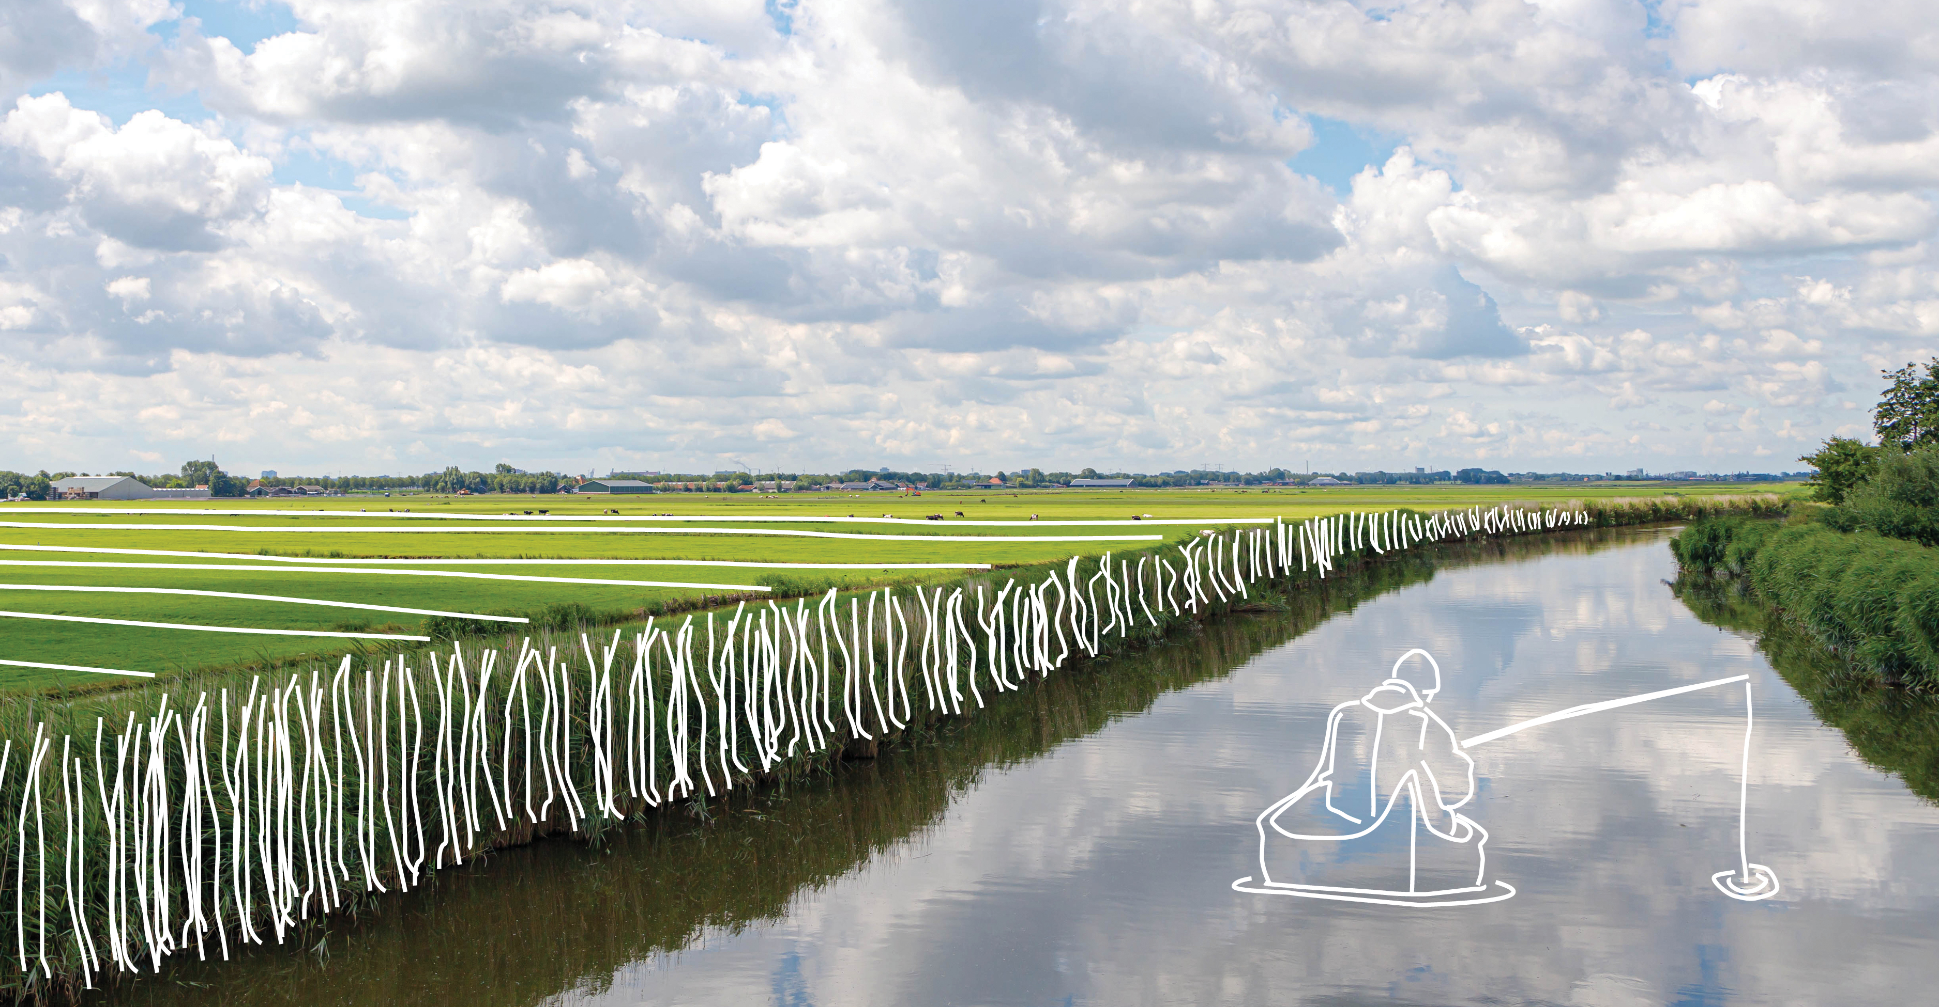

2 / 2