**Press release**

For immediate release

**Living together in harmony in the Montérégie’s agricultural zone**

**“OUR COUNTRYSIDE: A LIVING SPACE TO SHARE”**

**Column about agricultural odours**

**Montérégie, May 3rd, 2021** – At this time of year, certain seasonal odours linked with agricultural activities can be uncomfortable. The Montérégie UPA, 13 RCMs, and Greater Longueuil want to inform the public about the importance of using farm fertilizers. This initiative is part of the campaign to raise awareness about living together in harmony in the agricultural zone, which was launched with financial support from the Ministry for Agriculture, Fisheries, and Food (MAPAQ).

Although they are unpleasant to smell, manure and slurry from farm animal waste are natural fertilizers. They are important to the regeneration of arable soils. In other words, they feed the soil so that it can, in turn, feed us by growing plants, vegetables, and grains.

For several years, farmers have focused on new methods for limiting the impact of fertilization on soils. For example, farm machinery now allows manure to be applied closer to the soil through ramps, which reduces the projection of manure into the air and therefore reduces associated odours. Immediate incorporation is also a useful practice as it does not generate much odour, while also increasing the efficiency of fertilization.

Some farmers have planted wind-break hedges that also create a barrier against odours between agricultural properties and those of other residents. Others have preferred to store manure in watertight pits. Livestock farmers pay particular attention to manure storage by installing a roof over their storage pit, by planting woodlots as odour-breaks, or by improving processing of animal waste from their farm.

It is difficult to provide an odourless agricultural environment, but farmers are aware of the problem and are implementing effective techniques to reduce the effects. They are also regulated by environmental standards and work to mitigate the inconveniences associated with their activities.

1 / 2

Remember that this project, living together in harmony in the agricultural zone, has a regional scope. It aims to foster living together and dialogue between farmers and residents. The partners want to demystify beliefs, mitigate nuisances, and address issues related to agricultural work. It is important to the project’s initiators to highlight the multifunctionality of the agricultural zone as a place for living, working, and leisure.

**About the partners**

The project partners include: the RCMs of Acton, Beauharnois-Salaberry, Brome-Missisquoi, Haut-Richelieu, Haut-St-Laurent, Jardins-de-Napierville, Haute-Yamaska, Marguerite-D’Youville, Maskoutains, Pierre-De Saurel, Roussillon, Rouville, and Vallée-du-Richelieu, Greater Longueuil, the Montérégie UPA Federation (MUPAF), and the MAPAQ Montérégie regional office. These organizations are pooling resources and efforts to develop strategies and tools to ensure this campaign to raise awareness has a regional reach. The project was funded by the MAPAQ’s Territories program: Bio-food priorities and will continue through October 2021.

- 30 -

Sources:

Living Together Project:

Caroline Deschamps, Montérégie UPA Federation (MUPAF)

450-774-9154, extension 5227 [cdeschamps@upa.qc.ca](mailto:cdeschamps@upa.qc.ca)

Promotional materials for the campaign:

Brigitte Marcotte, Expansion PME

450-446-2880, extension 2703 bmarcotte@expansionpme.org

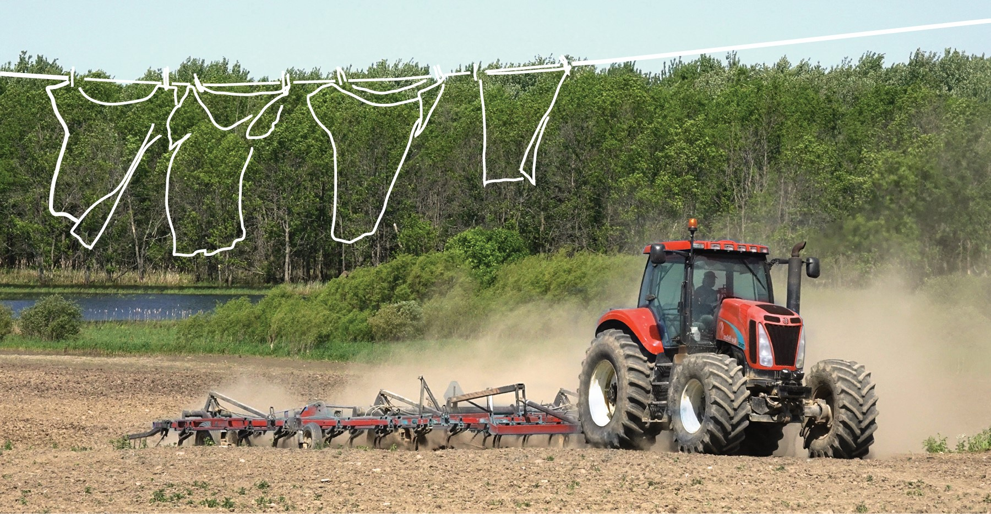

2 / 2